# Question 01:

# For the following IP Addresses, Identify the following:

## 1) Class (A, B, C, D, E)

## 2) Network-Host Division (Example: N.N.N.H)

## 3) Subnet Mask (Example: 255.0.0.0)

|  |  |  |  |
| --- | --- | --- | --- |
| Ip Addresses: | Class: | Networh-host division: | Subnet mask: |
| 193.34.23.1 | B | N.N.H.H | 255.255.0.0 |
| 199.80.60.110 | C | N.N.N.H | 255.255.255.0 |
| 224.254.254.254 | C | N.N.N.H | 255.255.255.0 |
| 108.80.10.1 | A | N.H.H.H | 255.0.0.0 |
| 120.1.1.1 | A | N.H.H.H | 255.0.0.0 |
| 12.11.12.22 | A | N.H.H.H | 255.0.0.0 |
| 66.77.88.80 | A | N.H.H.H | 255.0.0.0 |
| 223.254.254.254 | C | N.N.N.H | 255.255.255.0 |
| 100.100.100.100 | ‘A’ But Invalid as it is a broadcast address. | N.H.H.H | 255.0.0.0 |

# Question 02:

# Complete the following network in Packet Tracer: Please take screenshots when all configurations are done and PING is successful.

## Network-1:

## Capture screenshot of the “IP configuration” of PC

# 

## **Network-2:**

## **Capture screenshot of the “IP configuration” of PC**

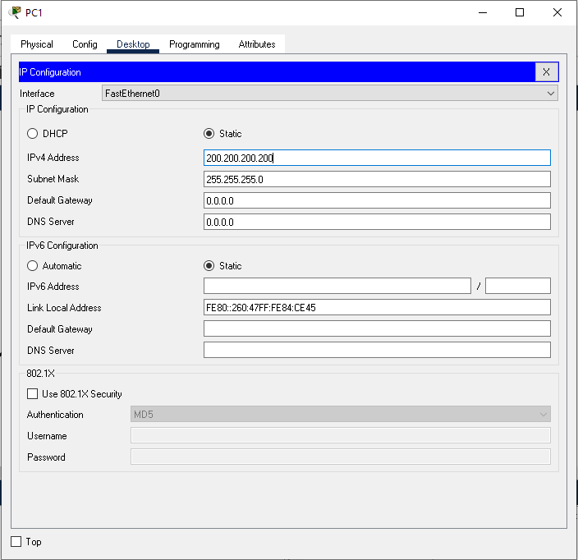

## Add a Router (2911):

## Capture screenshots of Both of the Router Interfaces

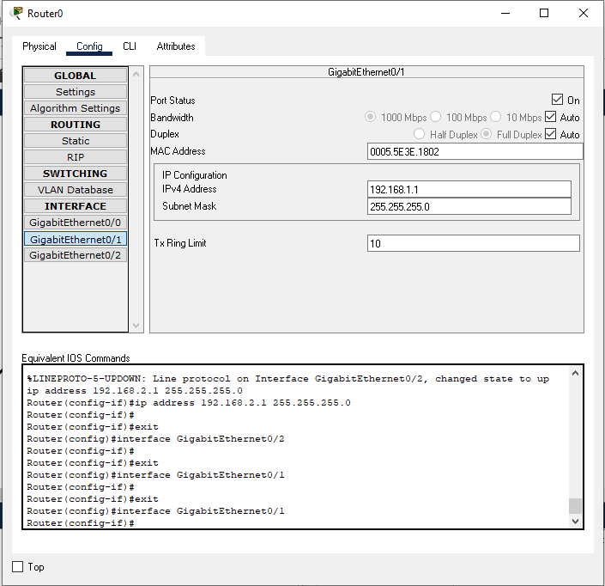

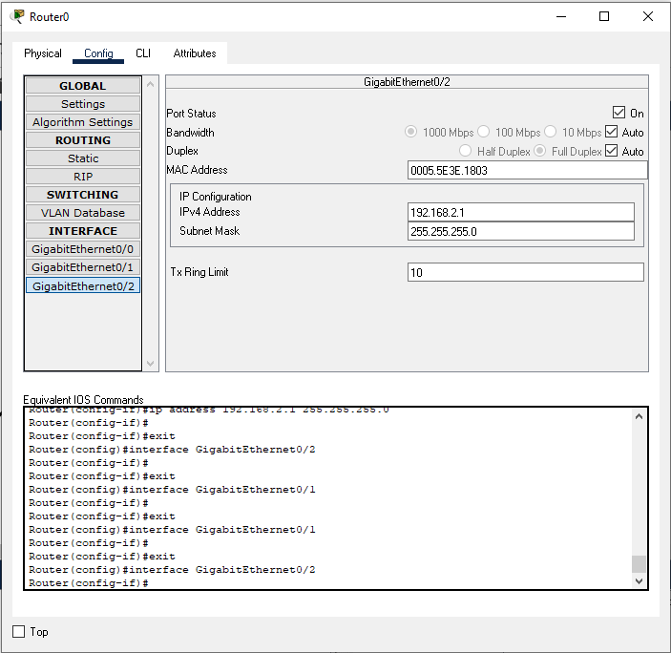

## Ping Screen shot:

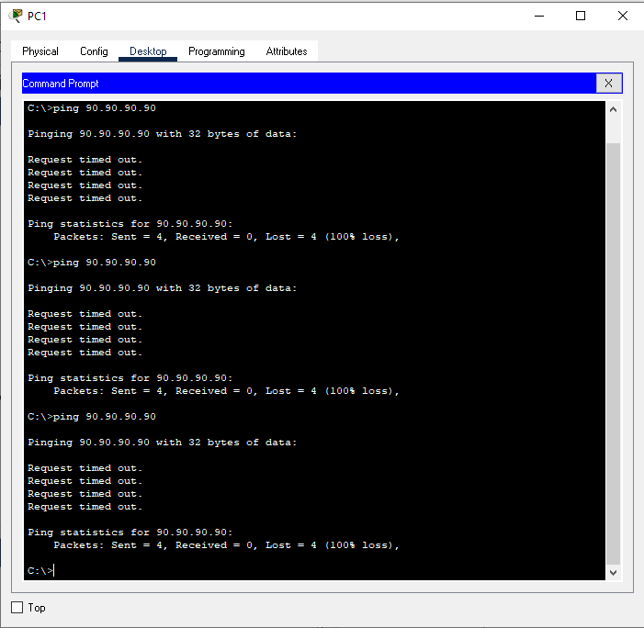

## Network Screen shot:

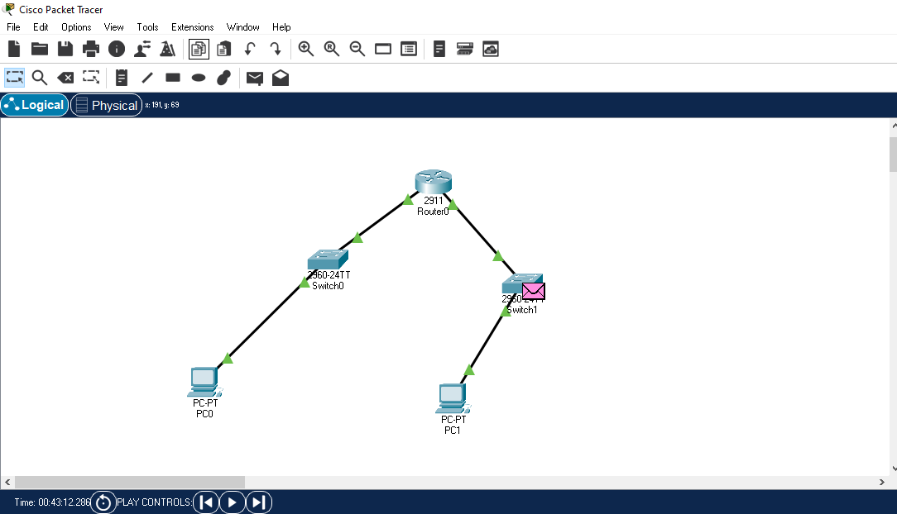

# Question 03:

# Implement Static Routing in the Network

## Network-1:

## First Pc:

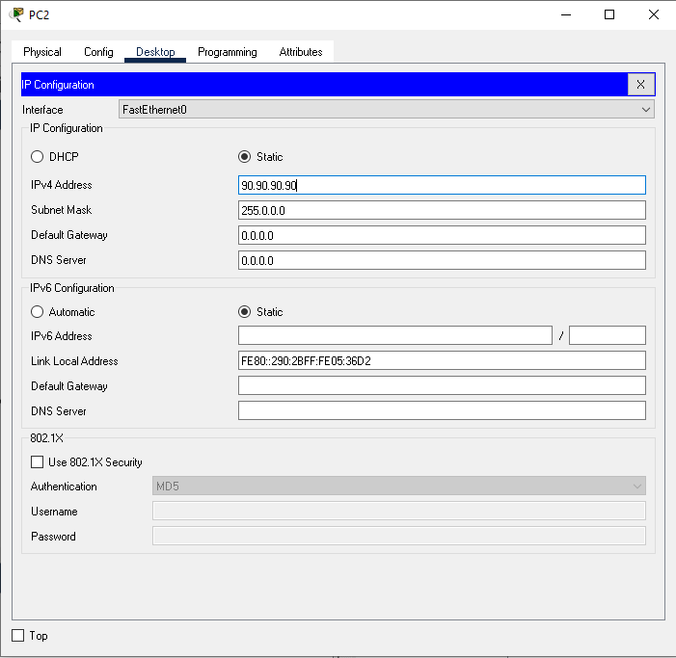

## Second Pc:

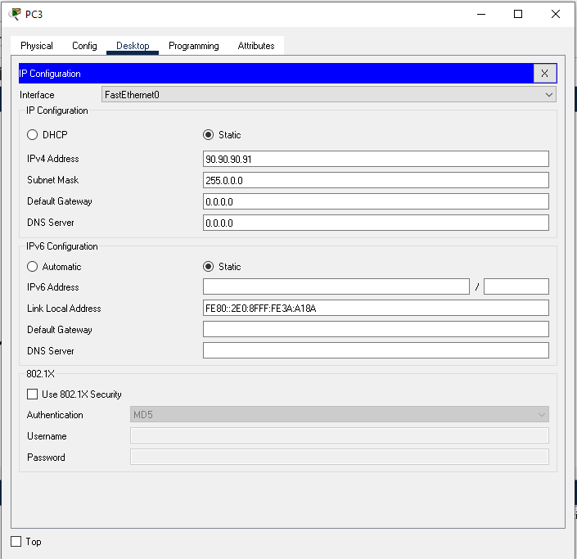

## Router 1:

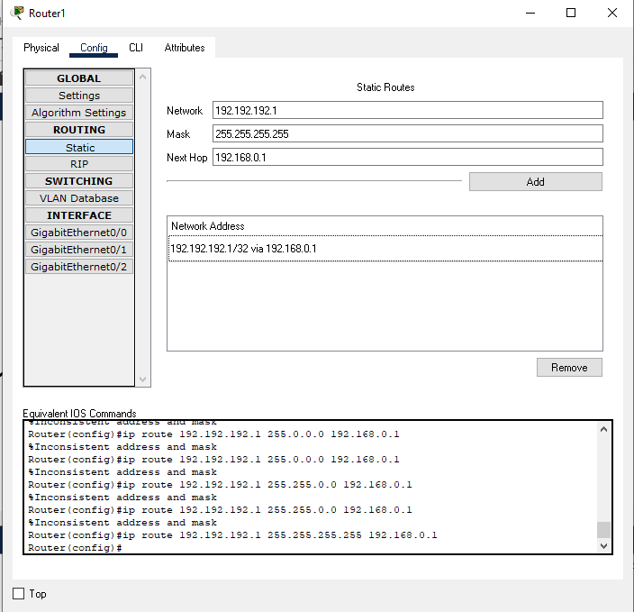

## Router 2:

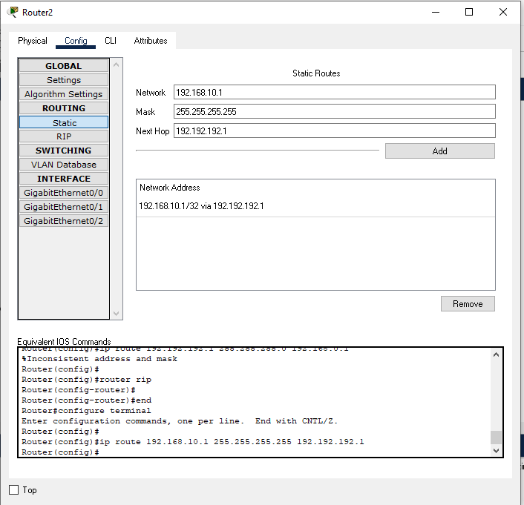

## Ping:

